PROTECTION AND PERMANENCY MEMORANDUM, 15-08

TO: Service Region Administrators
Service Region Administrator Associates
Service Region Clinical Associates
Regional Program Specialists
Family Services Office Supervisors

FROM: Tina Webb, Assistant Director
Division of Protection and Permanency

DATE: July 10, 2015

SUBJECT: Clarification of Initiation Timeframes and Receipt of Current Information on TWIST Intake Pages

PPTL 15-10 Timely Initiation of Reports and Initiation and Documentation of 2nd Incidents was issued on July 2, 2015. After receiving several staff comments regarding this release, this memorandum is being issued as a clarification.

- Initiation timeframes: A language clarification has been provided in the following SOP sections in order to clarify when initiation timeframes for after-hours reports actually begin. In these situations, the on-call SSW is not required to submit anything in TWIST prior to acceptance. The decision by the on-call FSOS to accept a report dictates when the initiation timeframe begins.
  - 2.10 Initiating the Report;
  - 20.1 Introduction to APS Investigation and Assessment; and
  - 27.3 Assessment, Documentation and Timeframes.
- Receiving current information on intake pages: There was a reporting error in PPTL 15-10 regarding how SSWs and FSOSes receive intake information via i-twist. Once the CI FSOS approves the intake, the report will populate to the investigative FSOS’s “i-twist Home” page, under the “My In-progress Tasks” column in real time, not under the “My Pending Approvals” column.
Additionally, PPTL 15-10 stated that workers and supervisors would receive “alerts” to inform them that they have a pending assignment or task to complete. There are no “alerts” that will notify staff regarding pending assignments. In order to view pending assignments, staff do need to refresh their screen and can then click on “Assessment” or “Individuals” to determine what actions need to be taken.
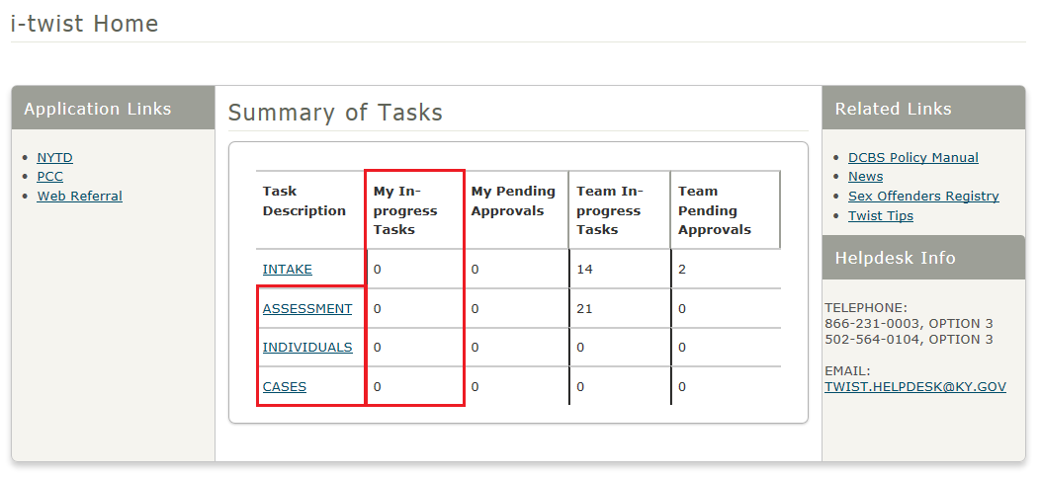

If you have any questions regarding this clarification, please contact:

Lucie Estill, Child Protection Branch Manager
Lucie.estill@ky.gov
(502) 564-2136, ext. 3568

